# CS 255 System Design Document Template

This template lays out all the different sections that you need to complete for Project Two. Each section has guidance to prompt your thinking. You will need to continually reference the interview transcript as you work to make sure that you are addressing your client’s needs. There is no required length for the final document. Instead the goal is to complete each section based on what your client’s needs are. Remove this note when you are finished, and replace all bracketed text with the relevant information.

## UML Diagrams

### UML Use Case Diagram

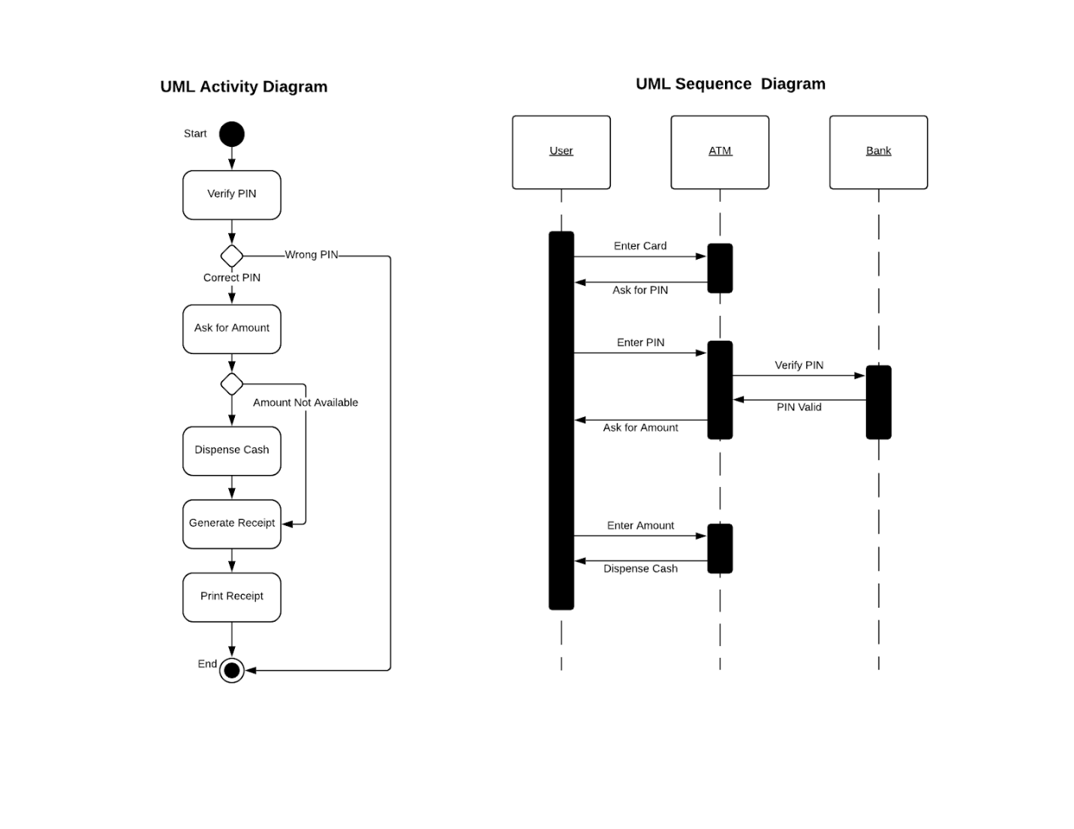

### UML Activity Diagrams Activity Diagram

### 

### UML Sequence Diagram

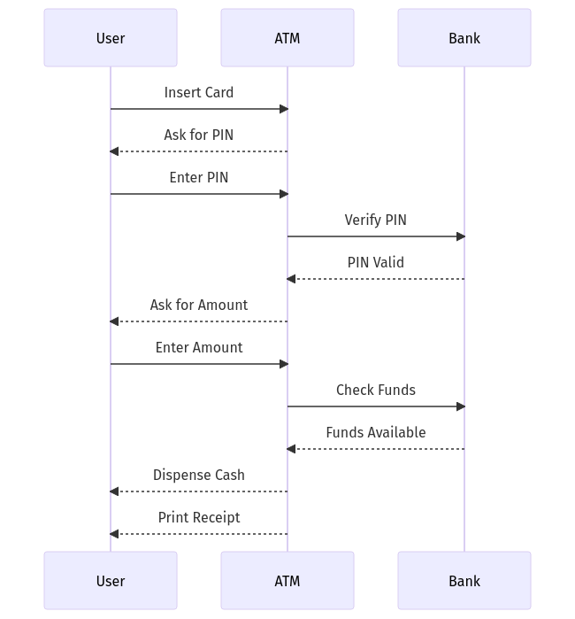

**UML Class Diagram**

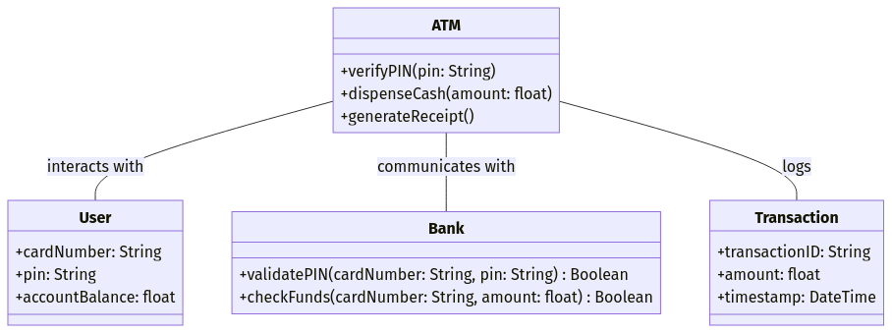

## Technical Requirements

***Hardware Requirements***

* ***ATM Device****:  
  The ATM will need a card reader to process user card details, a secure keypad for PIN entry, a cash dispenser module for withdrawing money, and a printer for generating receipts. It will also require a network module for communicating securely with the bank’s server.*
* ***Bank Server****:  
  High-performance servers will be needed to handle user authentication, transaction processing, and account balance checks. A secure database is also required for storing user account data and transaction history.*
* ***User Devices****:  
  If users are given the option to interact with their accounts remotely, they will need a mobile phone or computer for online access.*

***-Tools***

* ***Security Tools****:  
  The system will use encryption to protect PINs and transactions. Firewalls and other security tools will keep the system safe from hackers.*

***Software Requirements***

* ***ATM Software****:  
  The ATM needs software to handle PIN entry, verify PINs, dispense cash, and print receipts. This software will run on the ATM’s operating system.*
* ***Banking System Software****:  
  The bank will need software to verify PINs, check if funds are available, and handle transactions. A database system like MySQL or PostgreSQL will be needed to store account and transaction data.*
* ***Communication****:  
  The system will need secure ways to send data between the ATM and the bank server, like using HTTPS or similar protocols.*

***Infrastructure***

* ***Networking****:  
  The ATM needs a secure connection to the bank server, such as a VPN or dedicated line. A backup internet connection is also a good idea in case the main one fails.*
* ***Cloud and Backups****:  
  Data like logs and backups can be stored in the cloud to keep it safe.*
* ***Database Management****:  
  The system needs a centralized database for storing account details, PINs, and transaction data.*
* ***Security Measures****:  
  Admin access should require two-factor authentication, and the ATM itself should be physically secure to prevent tampering.*